**Lab 6 - Open Loop Systems**

Austin Huang and Matthew Rodriguez

**Figures**

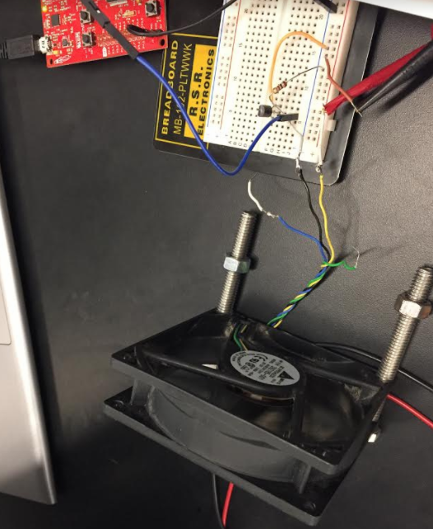

Figure 1: Fan being powered by MSP430 using MOSFET

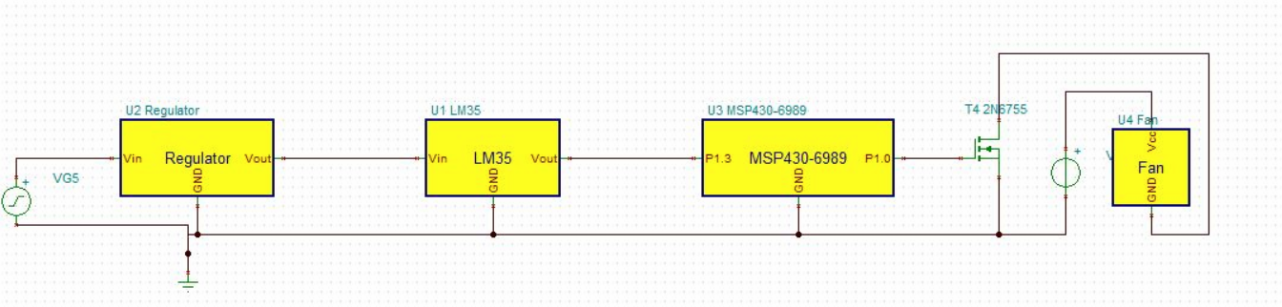

Figure 2: Tina-Ti schematic of temperature sensor and voltage regulator circuit

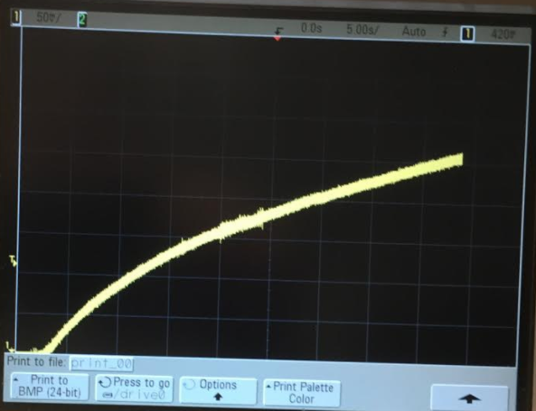

Figure 3: Voltage vs. Time graph from the oscilloscope

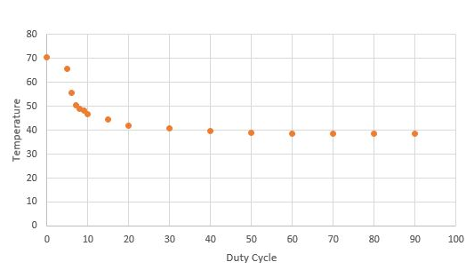

Figure 4: Graph of Temperature vs. Duty cycle

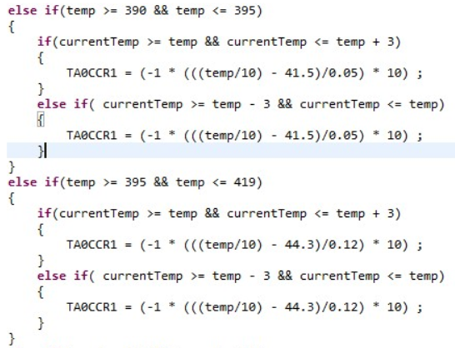

Figure 5: Code used to model system behavior

**Fan Control**

A fan is used to regulate the temperature of the voltage regulator. The fan was used to see if the signal from the MSP430 passing through the circuit would able to power the fan. The MSP430 is used to output a PWM signal to the fan. The circuit in Figure 1 was built and tested to power the fan.

**Voltage Regulator and Temperature Reading**

The output voltage of the temperature sensor determines the temperature it is reading. The calibration ratio is seen to be 10mV per degree Celsius. Using the given ratio, any output voltage measured can be converted to a corresponding temperature in degrees Celsius.

A 5V voltage regulator was used to regulate a 15V-20V input. The range was chosen to be a high voltage for the regulator to heat up. This would allow for testing of the functionality of the temperature sensor. A simple circuit was built to test the temperature sensor. The schematic built in Tina-Ti can be seen in Figure 2.

The result can be seen in the Voltage vs. Time graph in the oscilloscope as seen in Figure 3. The voltage is seen to increase over time as the temperature sensor reads the temperature of the voltage regulator.

**System Modeling**

A system can be modeled for the temperature and duty cycle of the fan. A fan being controlled by various PWM cycles from the MSP430 was used to cool the voltage regulator. The different values that the temperature sensor read because of the different PWM cycles was recorded. From the recorded data, a graph in Figure 4 was constructed to model the relationship of the duty cycle of the fan to the temperature of the regulator. A piece-wise linear function will be created to model the system in Figure 4 (Voltage vs. Time graph). It will be used to implement the code.

**Open Loop Control System**

A control system can be designed from a coding standpoint given the system model of the voltage regulator. Since the data models the relationship between the duty cycle of the fan to a temperature, the behavior of the output of the MSP430 can be coded. The PWM duty cycle output will vary according to a desired temperature inputted. The code is attached in the repository.

**Code**

To implement the design, set up the circuit as shown in Figure 2. Next, compile the attached code in the repository to implement the functionality from the MSP430.

The code shown in Figure 5 controls the behavior of the fan. The code uses TimerA to set the duty cycle of the fan. The duty cycle that is set is dependent on the desired temperature and current temperature of the voltage regulator. As seen in the code, if and else-if statements are used to control the actions of the fan. An equation is used to calculate the duty cycle that will allow for the temperature to remain steady. The duty cycle calculation is pulled from the graph in Figure 4. The slope and y-intercept are found to create an equation modeling each part of the graph. The duty cycle is then calculated based on the equation that fits each portion of the graph.